**Selected Problems - Chapter 8**

**1.4** (a)

|  |  |  |  |
| --- | --- | --- | --- |
| Q | TC | AVC | MC |
| 0 | 0 | --- | --- |
| 1 | 30 | 30 | 30 |
| 2 | 58 | 29 | 28 |
| 3 | 82 | 27.3 | 24 |
| 4 | 106 | 26.5 | 24 |
| 5 | 134 | 26.8 | 28 |
| 6 | 166 | 27.7 | 32 |
| 7 | 202 | 28.9 | 36 |
| 8 | 242 | 30.3 | 40 |
| 9 | 286 | 31.8 | 44 |
| 10 | 334 | 33.4 | 48 |

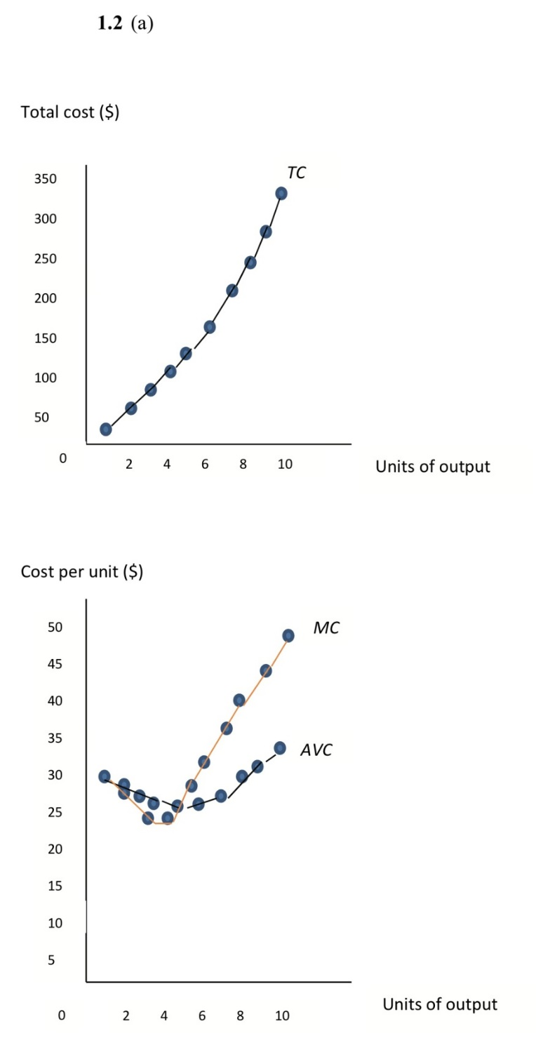

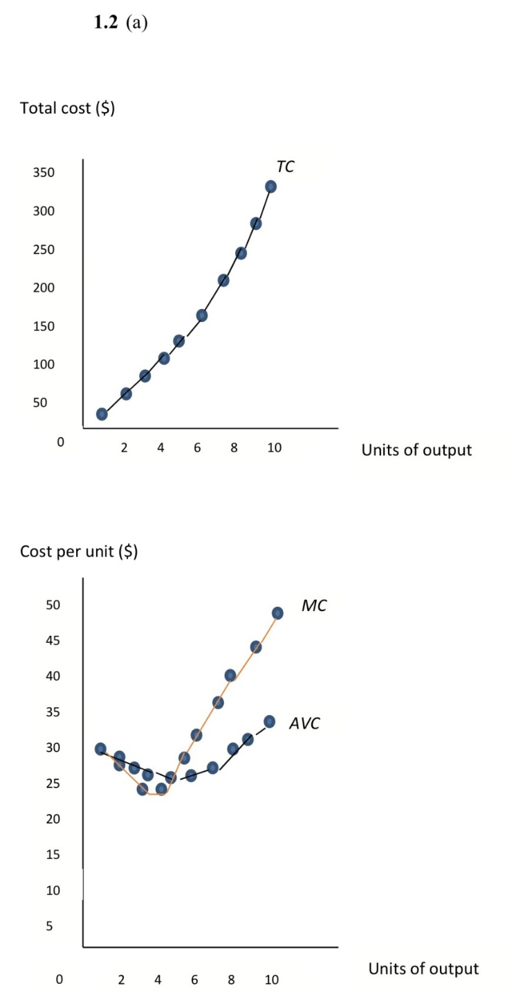

(b) Yes, given diminishing returns, *MC* may fall at first, but should eventually rise with output.

(c) When *MC* is below *AVC*, *AVC* falls; when *MC* is above *AVC*, *AVC* rises. At 3 units of output, *MC =* 24 < *AVC* = 27.3; thus, *AVC* falls. At 6 units, *MC* = 32 *> AVC* = 27.7; thus, *AVC* rises.

(d) Marginal cost is the added cost of the resources needed to increase output 1 unit. The *MC* of the sixth unit of output, for example, is $32: 5 units of *K* at $4 each plus 2 units of *L* at $6 each.

**2.5** (a)

|  |  |  |  |  |  |  |
| --- | --- | --- | --- | --- | --- | --- |
| q | TC | TFC | TVC | AVC | ATC | MC |
| 0 | $50 | $50 | $0 | — | — | — |
| 1 | 75 | 50 | 25 | 25.0 | 75.0 | 25 |
| 2 | 80 | 50 | 30 | 15.0 | 40.0 | 5 |
| 3 | 90 | 50 | 40 | 13.3 | 30.0 | 10 |
| 4 | 110 | 50 | 60 | 15.0 | 27.5 | 20 |
| 5 | 140 | 50 | 90 | 18.0 | 28.0 | 30 |
| 6 | 175 | 50 | 125 | 20.8 | 29.2 | 35 |
| 7 | 220 | 50 | 170 | 24.3 | 31.4 | 45 |
| 8 | 280 | 50 | 230 | 28.8 | 35.0 | 60 |
| 9 | 360 | 50 | 310 | 34.4 | 40.0 | 80 |
| 10 | 480 | 50 | 430 | 43.0 | 48.0 | 120 |

(b)

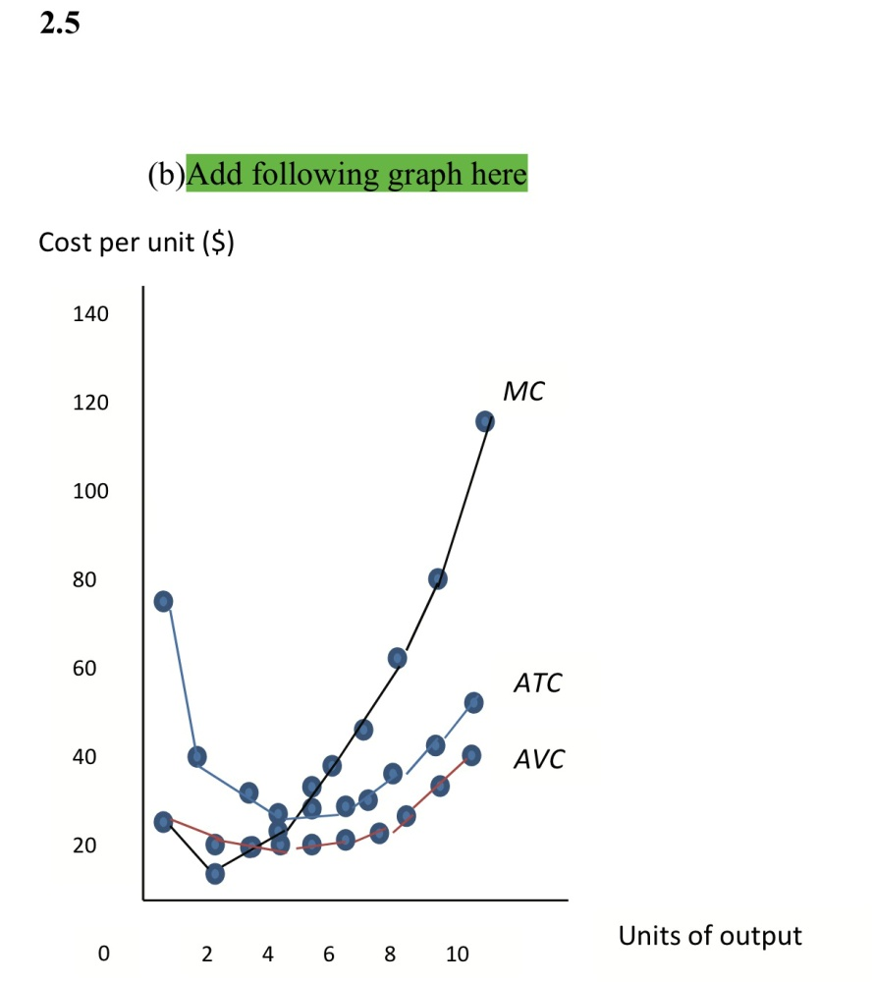

When *MC* is below *ATC* (*AVC*), *ATC* (*AVC* ) is decreasing. When *MC* is above *ATC* (*AVC*), *ATC* (*AVC* ) is increasing.

(c) 4 units

*TR* = 4 x $20 = $80

*TR – TC =* $80 – $110 = –$30; loss of $30

(d) 8 units

*TR* = 8 x $60 = $480

*TR – TC =* $480 – $280 = $200 profit